**Two Days workshop on “Biotechnology”**

**For Undergraduate Students**

**Organised by**

**Department of Botany & Zoology, Kokrajhar Govt. College, Kokrajhar**

Date: 23 rd May & 24th May, 2025

Venue: Seminar Hall (B Block ) and Zoology Lab

A **Two Days workshop on “Biotechnology” for Undergraduate Students is Organised by Department of Botany & Zoology, Kokrajhar Govt. College, Koira jhar .**

**Aim : To give a hands on knowledge on Gene mapping, DNA isolation, and Gel Electrophoresis to undergraduate students.**

**10:10 am - The program began with Welcome address by Dr. Nijira Brahma, Asstt. Professor& HoD Dept. of Zoology.**

**10:15 am - The Inaugural Adress was given by Dr. Gauri Shankar Narzary, HoD, Dept. of Geography & Coordinator of IQAC, Kokrajhar Govt. College.**

**10:20 am - Dr. Dhanajay Narzary, HoD, Dept. of Botany also gave a introductory speech about the Workshop.**

**Inaugural Adress by**

**Dr. Gauri Shankar Narzary, HoD, Dept. of Geography & Coordinator of IQAC, Kokrajhar Govt. College.**

**Resource persons:**

1. **Mr. Bhishma N. Swargiary, Asstt. Professor, Dept. of Botany.**
2. **Dr. Hwiang Narzary, Asstt. Professor, Dept. of Botany.**

**Day 1, 23/05/2025**

**Guest : 1**

**Teachers: 11**

**Students: 60**

**Total attended : 72**

**Program**

**Technical session: 10:45 am**

**Topic: Construction of gene map.**

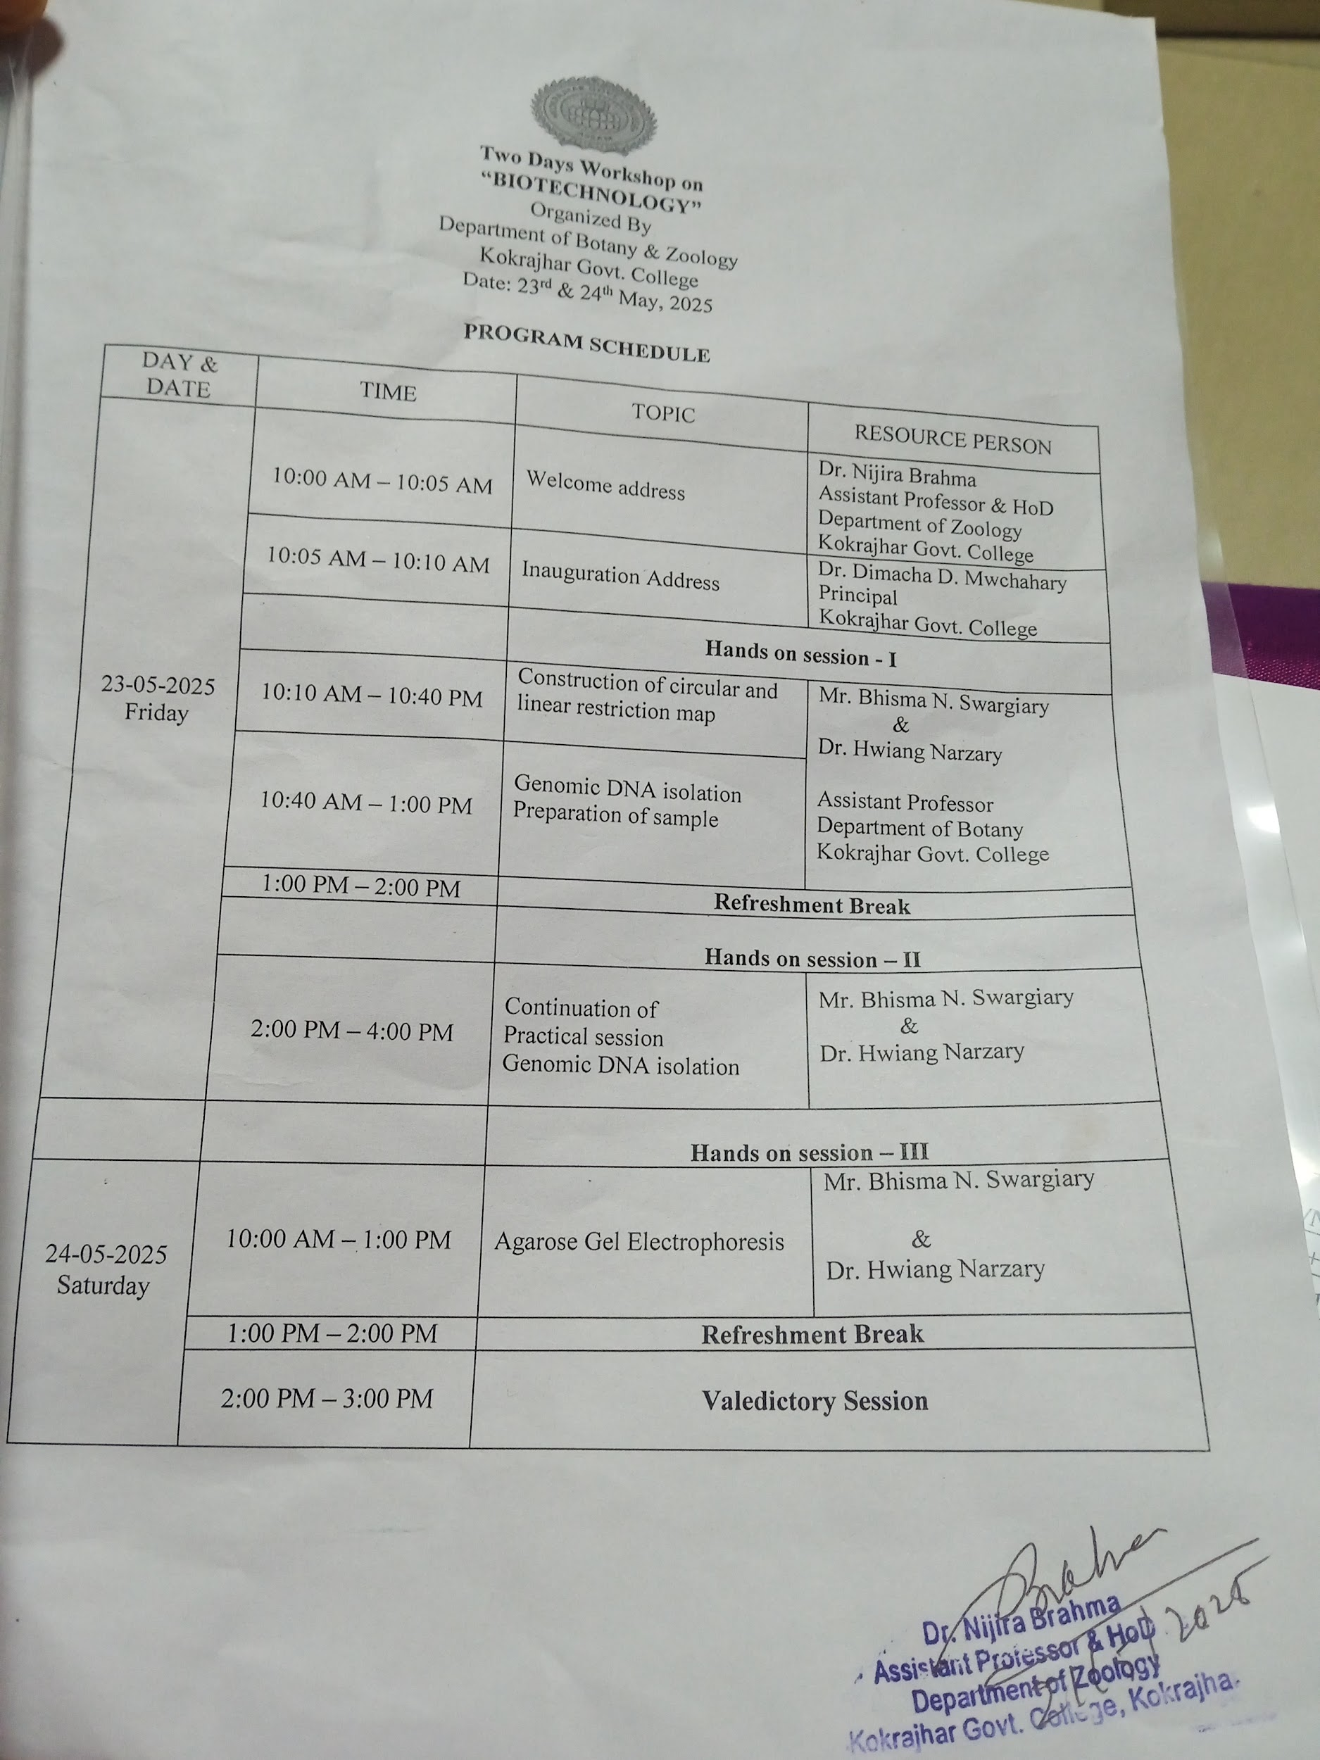

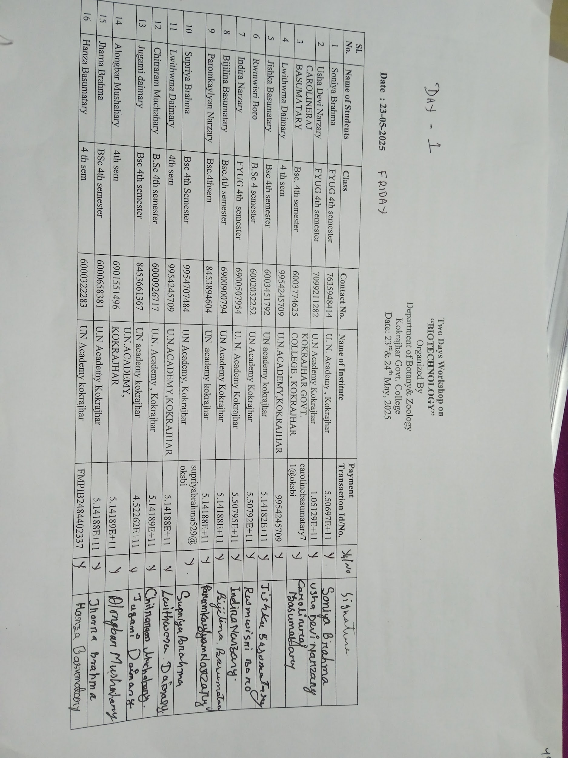

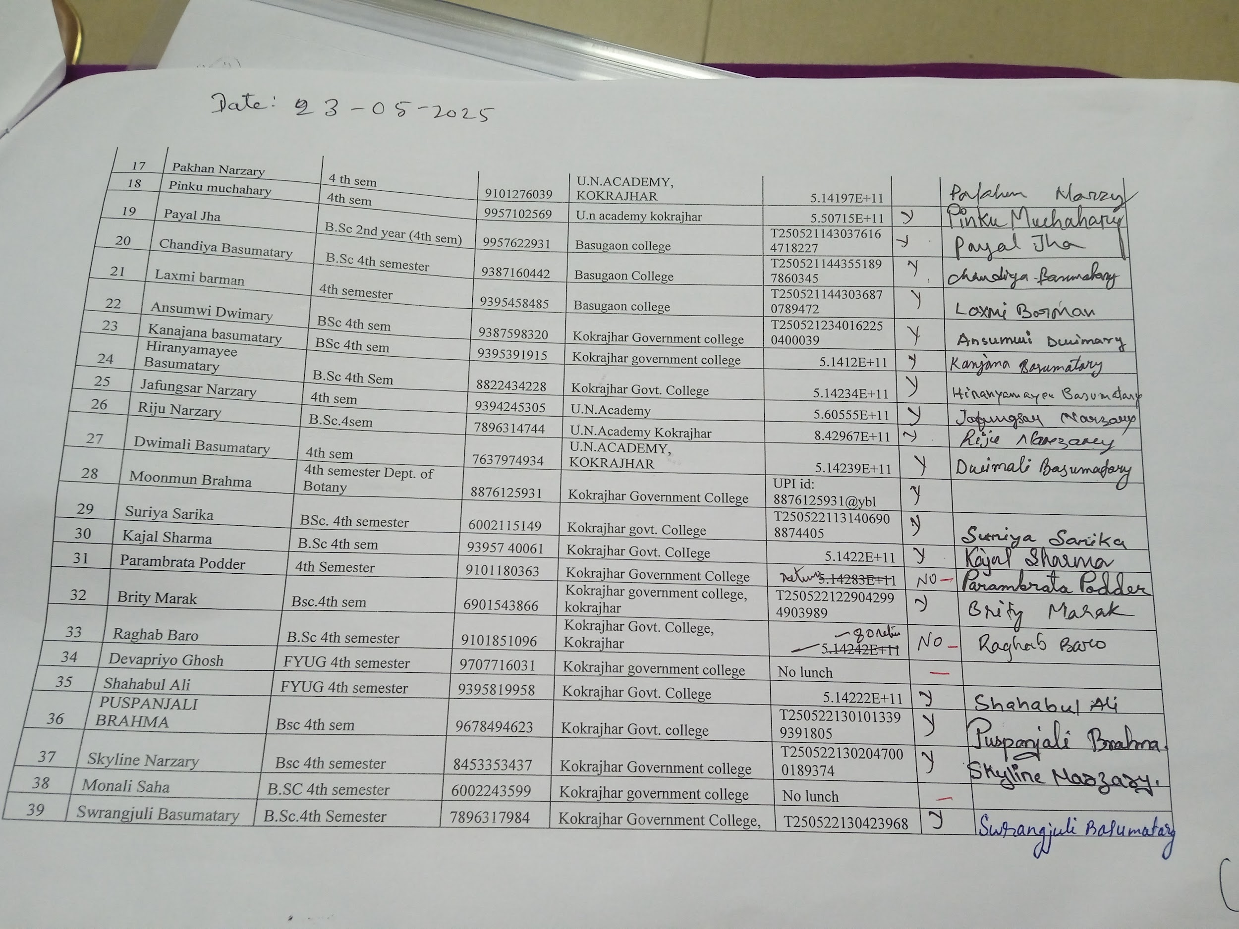

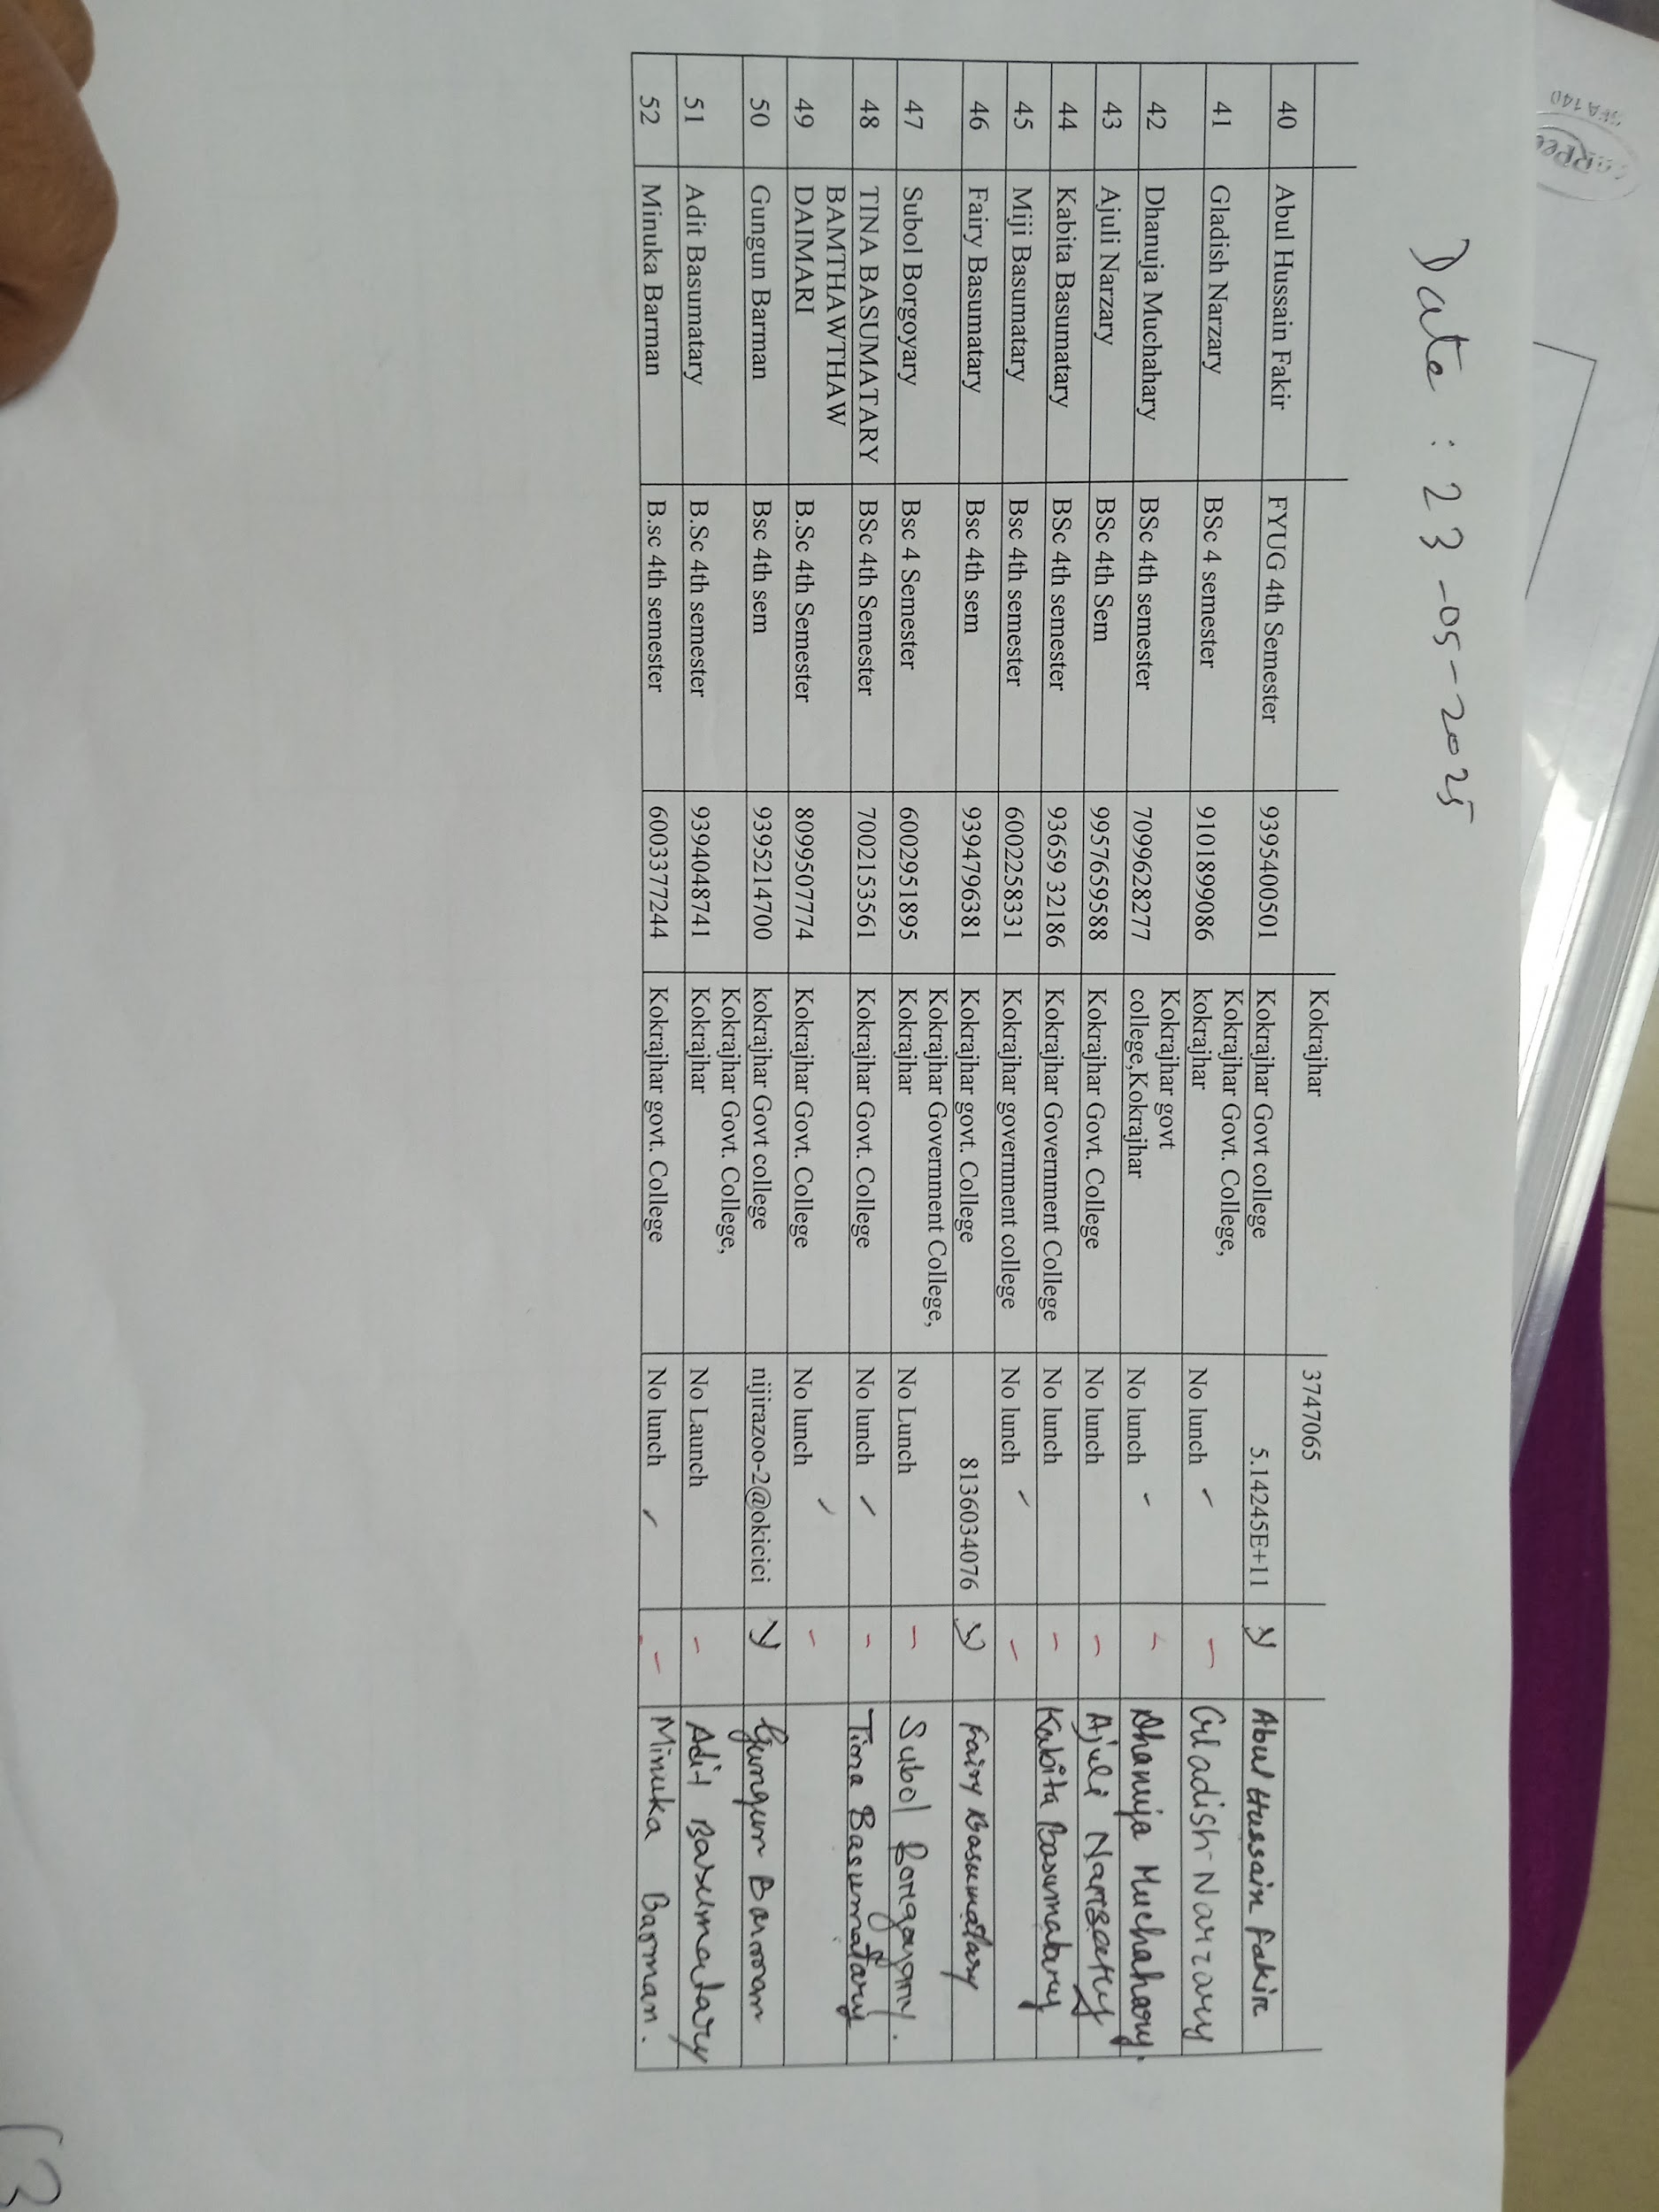

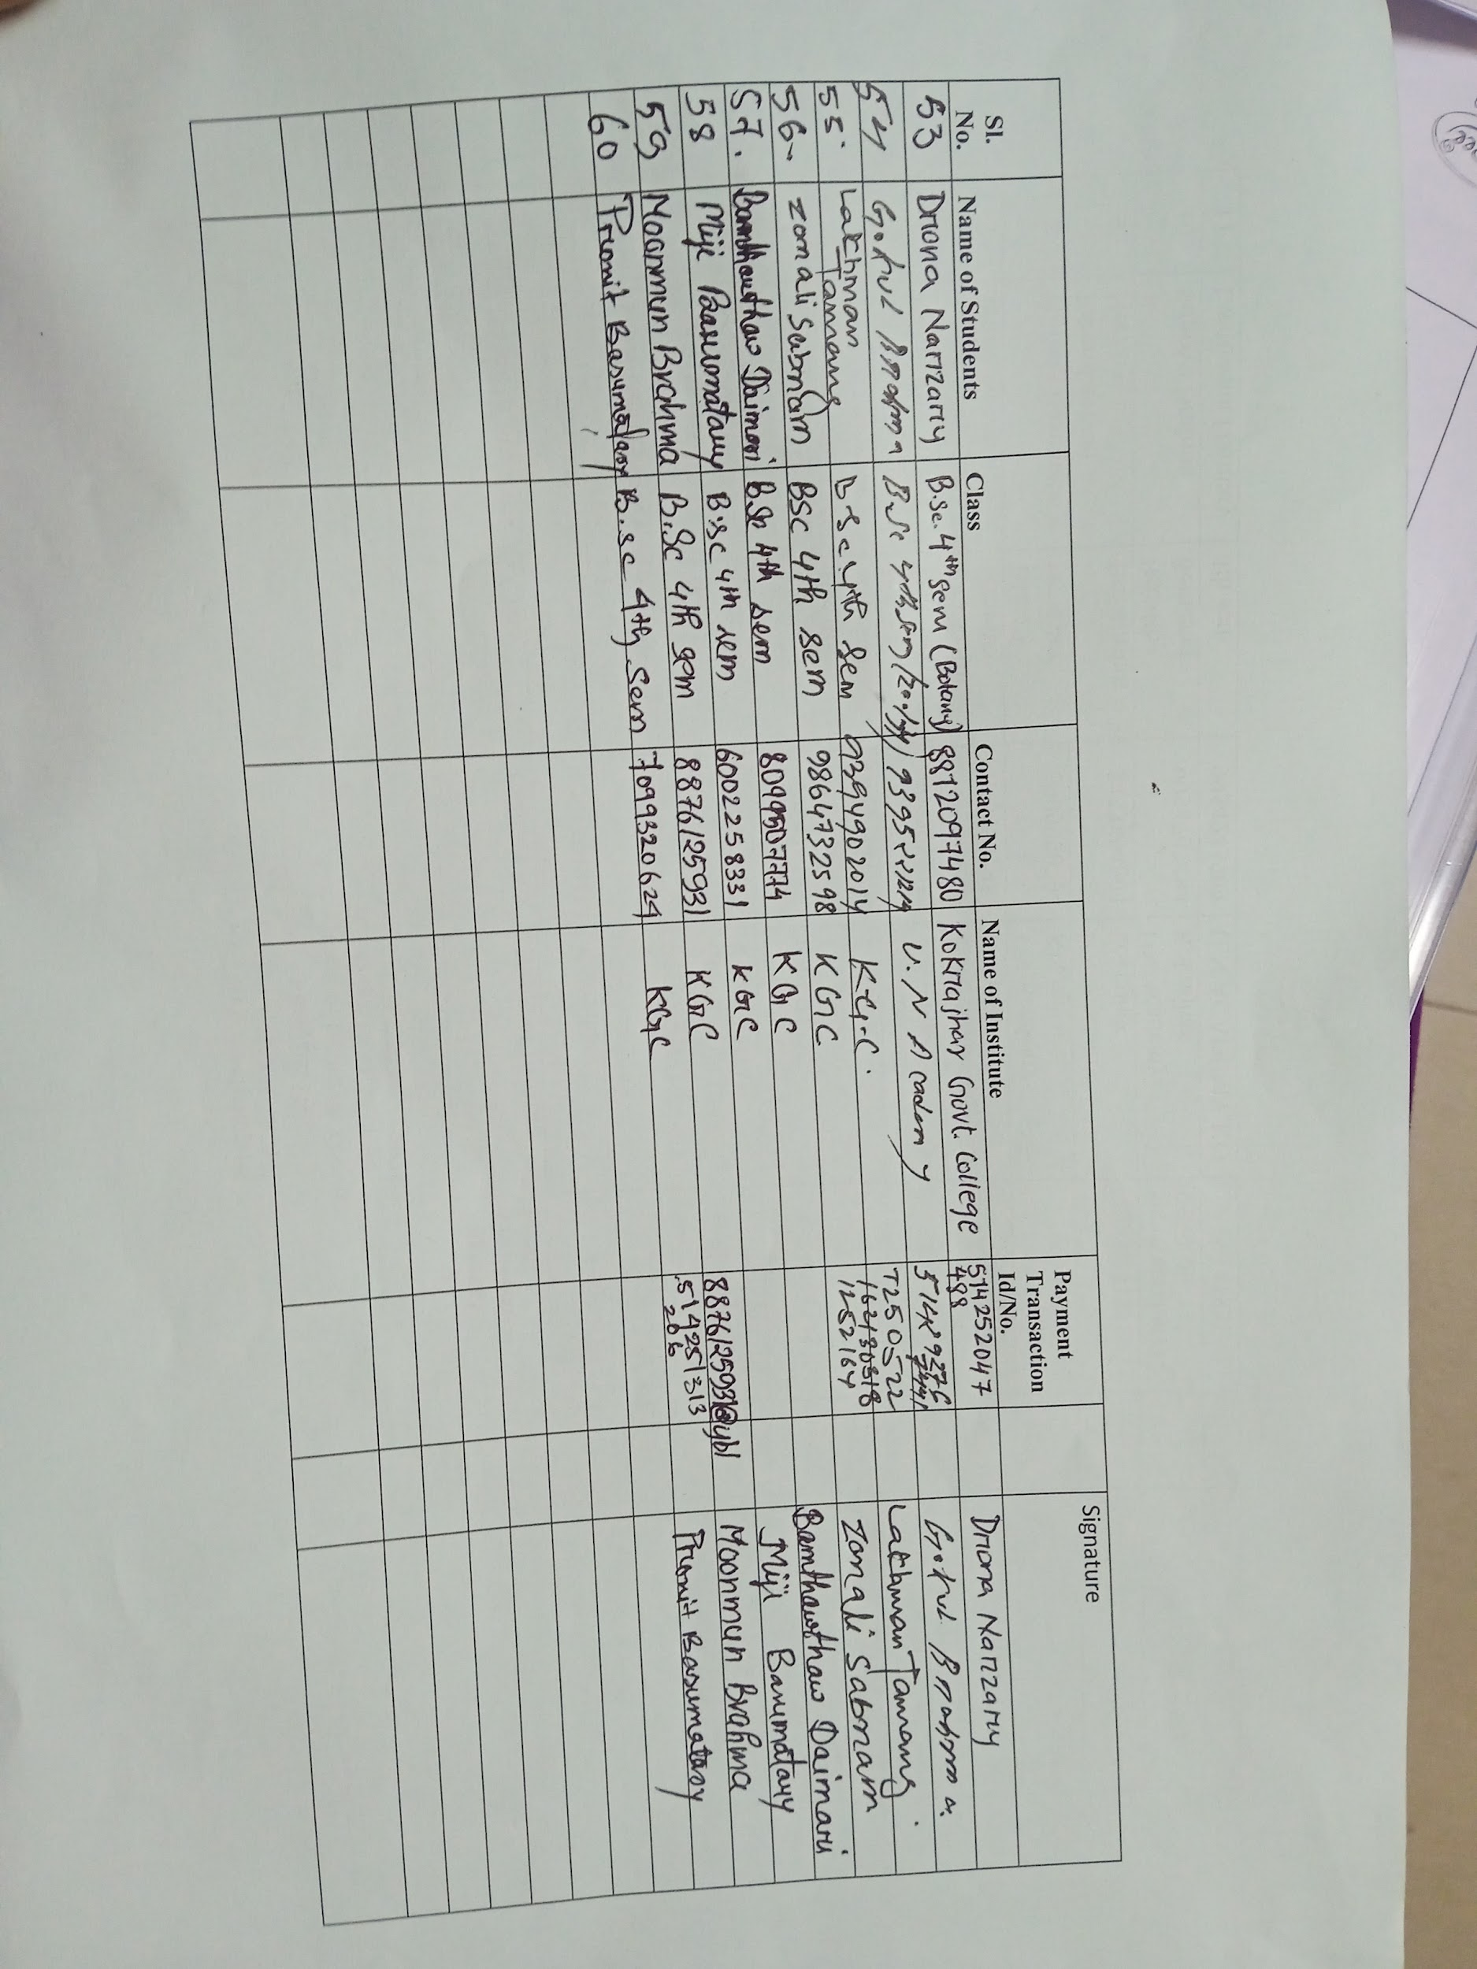

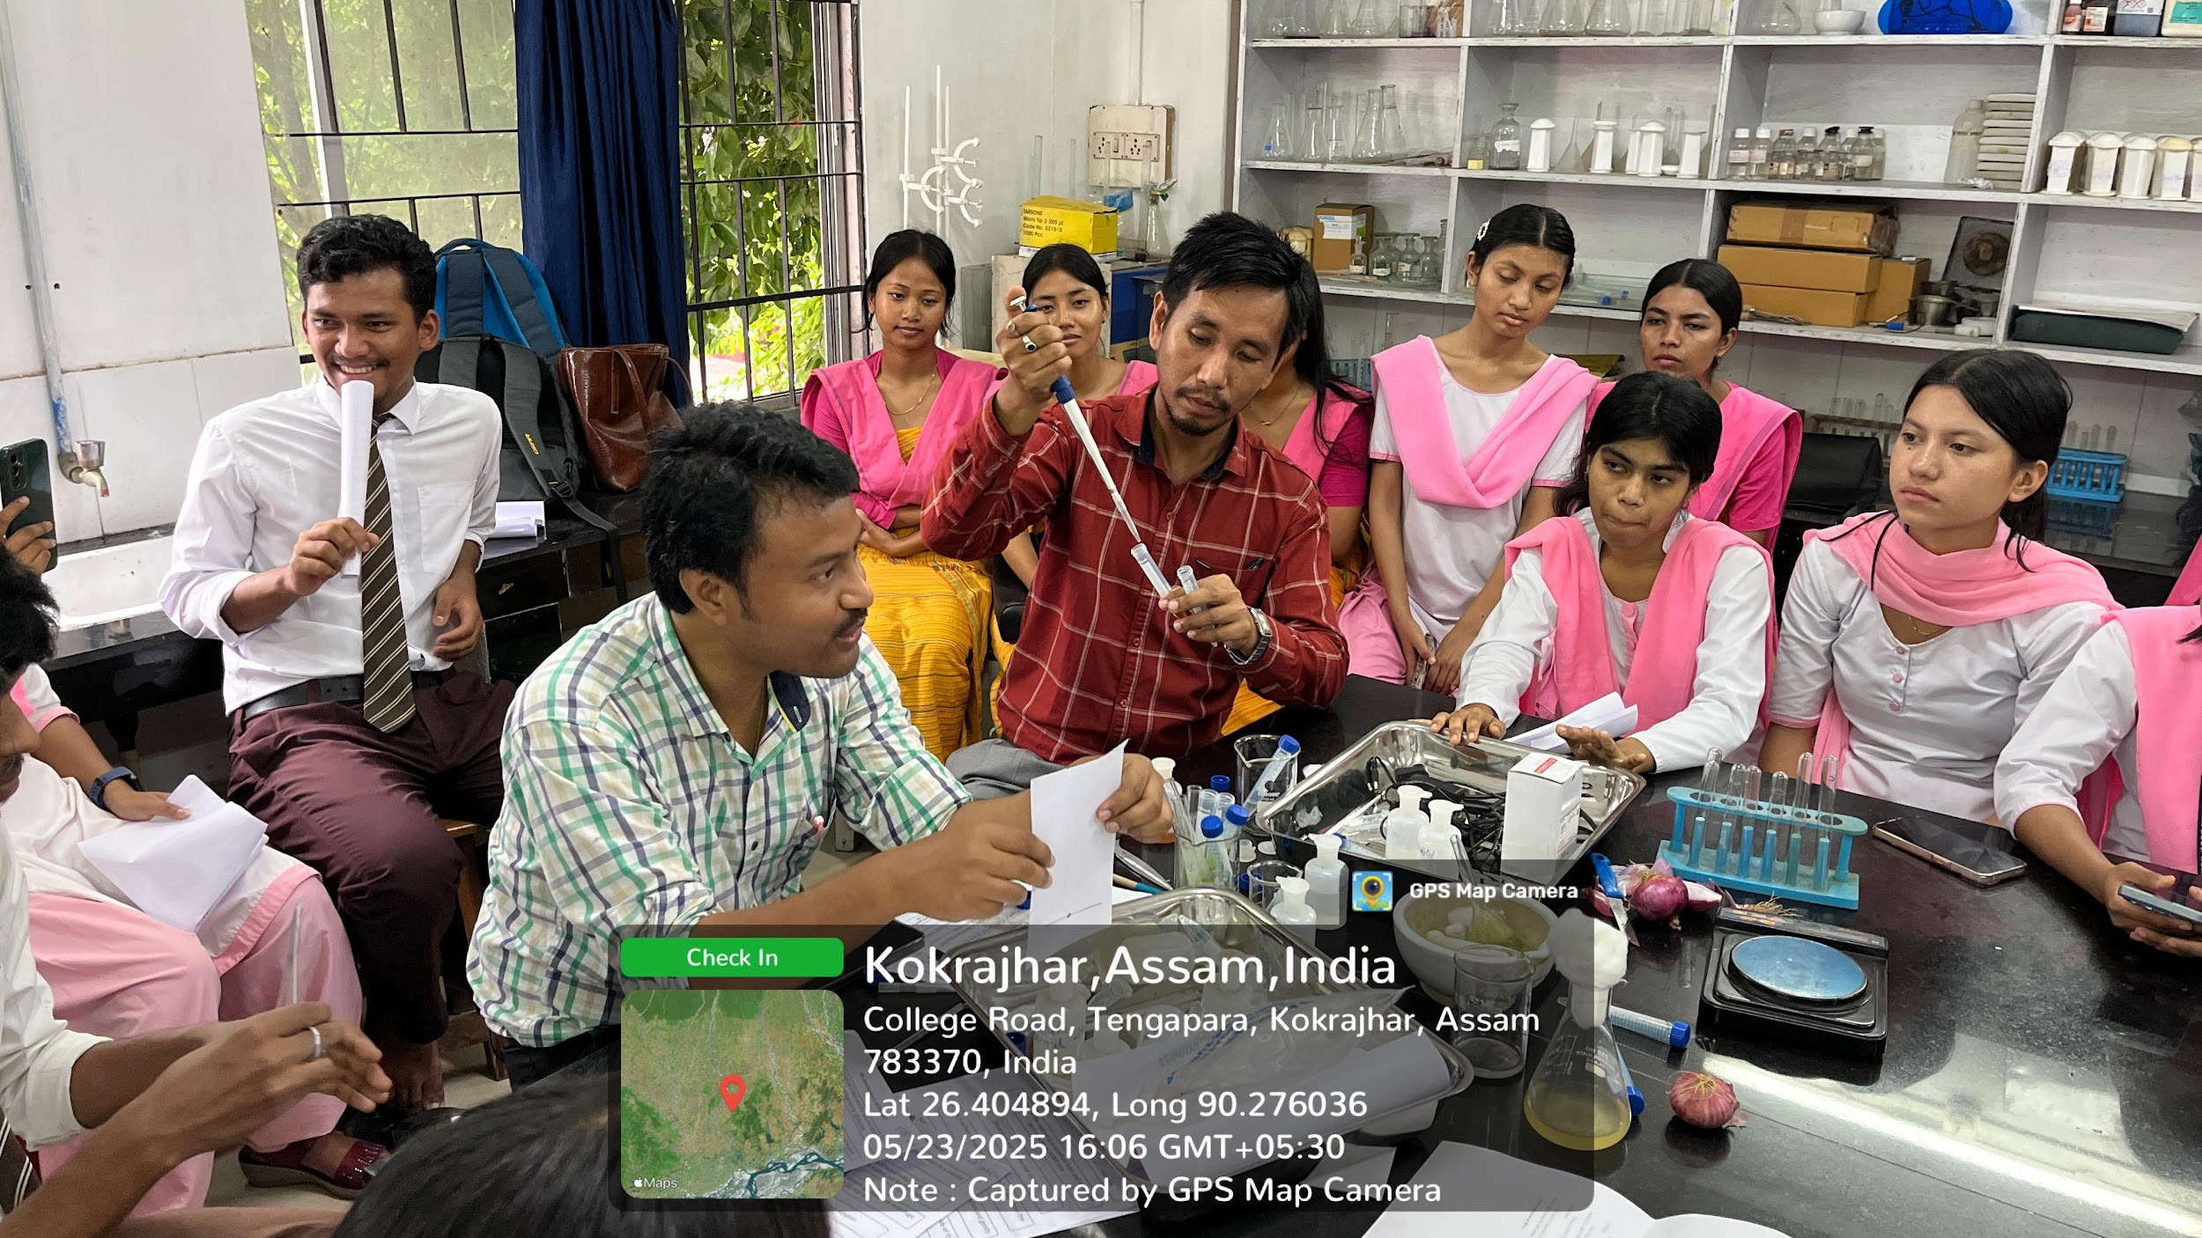

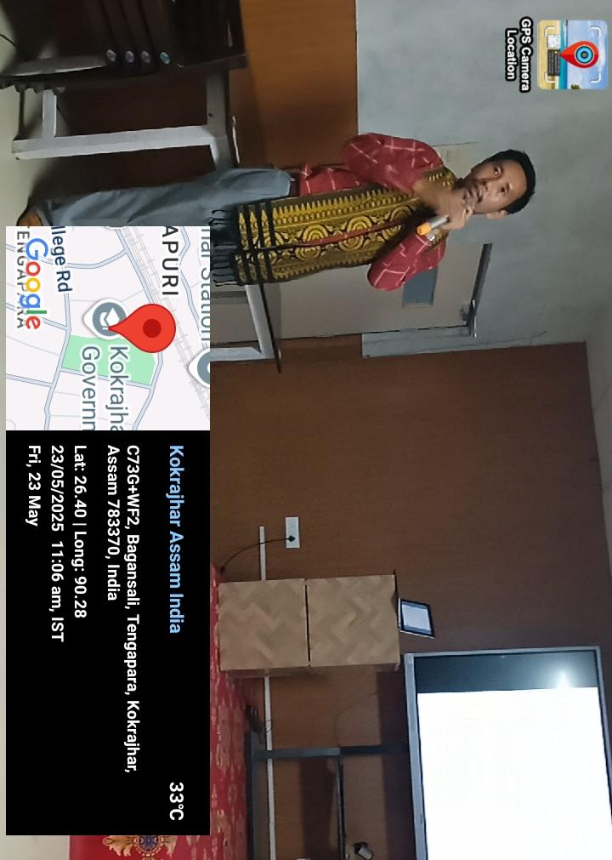

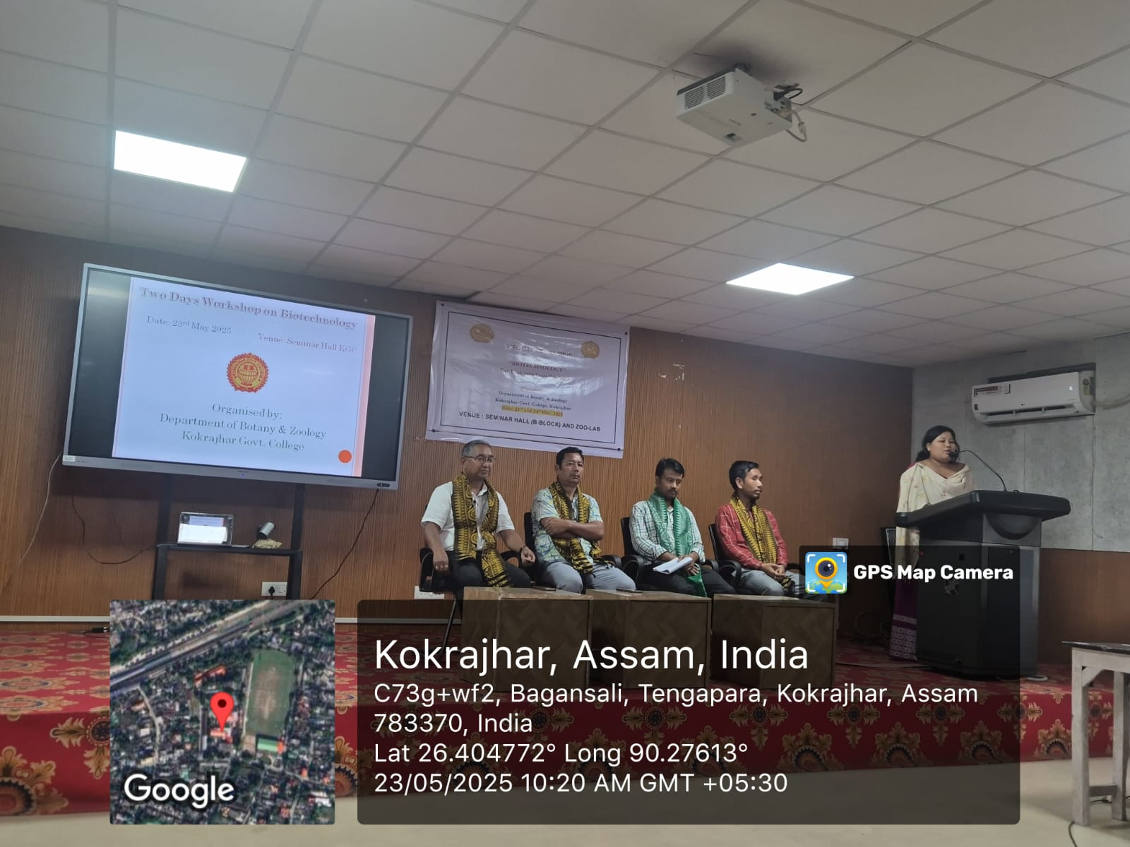

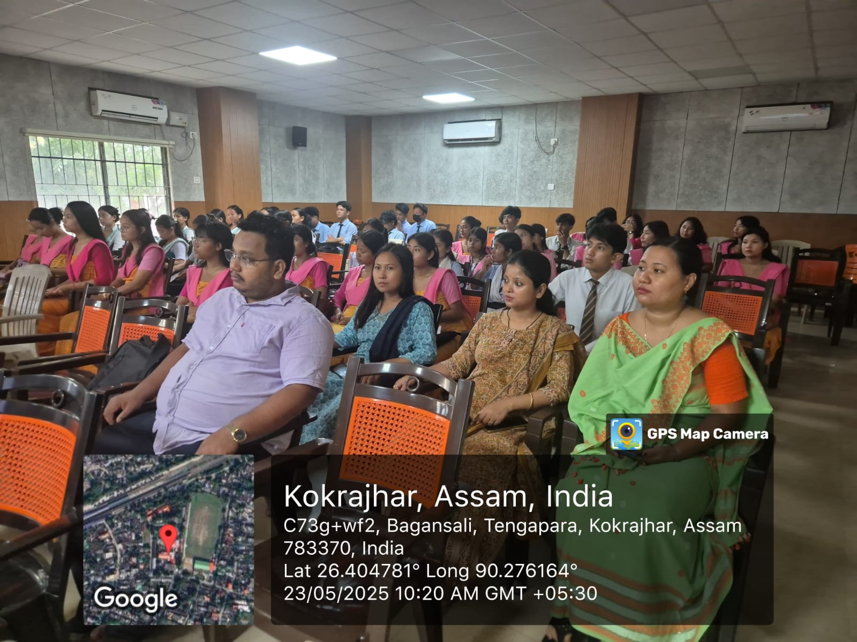

**Day 2**

**24-05-2025**

**DNA isolation and**

**Gel electrophoresis**

